Internship Data
S.NO | PHOTO | Name of the Student | Rollnumber | Name of the Company | Duration
1 | 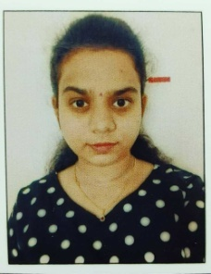 | A. Spandana | 20BF1A1202 | Skill vertex | 1 month
2 | 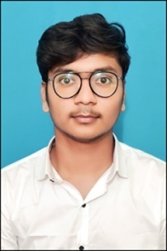 | N. Druva sadvik kumar | 20BF1A1238 | Mentorskool | 6 months
3 | 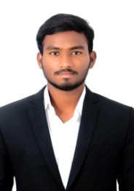 | k.chandu | 20BF1A1224 | IBM SkillsBuild | 5 weeks
4 |  | MADDILA CHARAN | 20BF1A1229 | Green Tree SoftTech | 1 Month
5 | 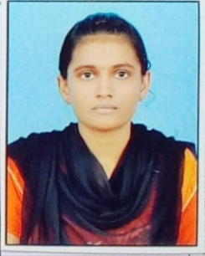 | Nelakurthi Meghana | 20BF1A1237 | Thinkchamp | 2 months
6 | 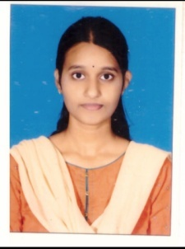 | Tallapaneni Asritha | 20BF1A1257 | Thinkchamp | 2 months
7 | 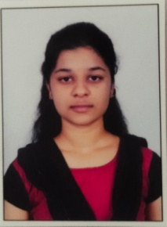 | Bedthur Preethi | 20BF1A1206 | 1stop | 1.5 months
8 | 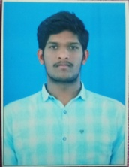 | Bellam Sanath Kumar | 20BF1A1210 | IBM SkillsBuild | 5 weeks
9 | 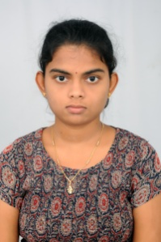 | Manchi Deekshitha | 20BF1A1230 | SDSC SHAR | 1 Month
10 | 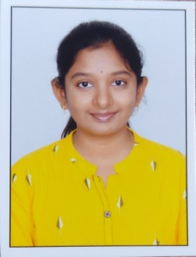 | Samudrala Yuva Varnika | 20BF1A1249 | 1stop | 1.5 months
11 | 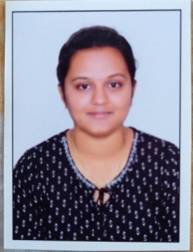 | Papudippu Sandhya | 20BF1A1243 | 1stop | 1.5 months
12 | 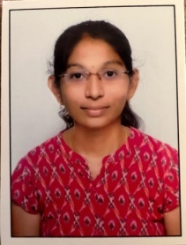 | Sirigiri Sireesha | 20BF1A1256 | 1stop | 1.5 months
13 |  | S. Sravani | 20BF1A1247 | 1stop | 1.5 months
14 |  | P. N. Sravani | 20BF1A1242 | 1stop | 1.5 months
15 | 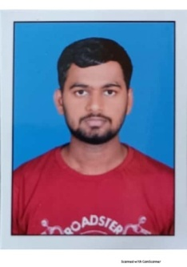 | Kasturi Dileep Chakravarthi | 20BF1A1223 | 1Stop | 1.5 Months
16 | 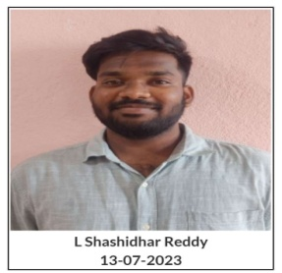 | L Shashidhar Reddy | 20BF1A1227 | Green Tree SoftTech | 1 Month
17 | 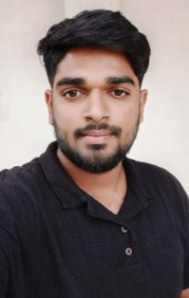 | C Mallikarjuna | 20BF1A1212 | 1stop | 1.5 Months
18 |  | G Likhitha | 20BF1A1219 | Skill Vertex | 1month
19 | 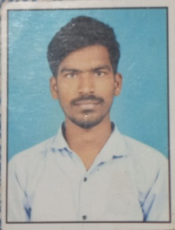 | S Uday Kiran | 20BF1A1248 | 1stop | 1.5 months
20 | 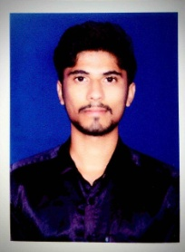 | Shaik Abdul Khader | 20BF1A1253 | SIVA SAI TECHNOLOGY | 18 weeks
21 |  | C Prasad | 20BF1A1211 | 1Stop | 1.5 months
22 |  | M LIKHITHA PRIYA | 20BF1A1232 | 1stop | 1.5 months
23 |  | P Prem Kumar | 21BF5A1205 | 1stop | 1.5 months
24 | 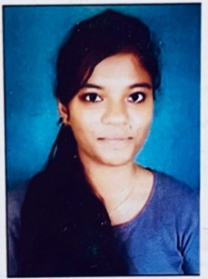 | T.Navya Sree | 20BF1A1258 | Skill vertex | 1 month
25 |  | M Naveen | 20BF1A1228 | 1Stop | 1.5 months
26 |  | N Vishnu | 20BF1A1236 | Oasis Infobyte | 1 month
27 | 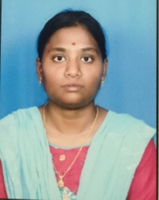 | S.Jahnavi | 20BF1A1252 | Accenture | 1 month
28 |  | L. E. Revathi | 20BF1A1226 | SIVA SAI TECHNOLOGY | 18 weeks
29 |  | Ashadi Dinesh | 20BF1A1204 | Salesforce Developer Virtual Internship | 3 Months
30 | 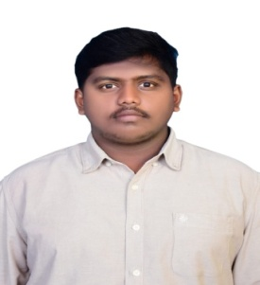 | Bathala Akshay | 20BF1A1208 | APSCHE- EDUSKILLS | 2 months
31 | 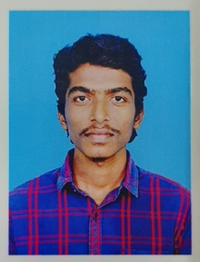 | A Sravankumar | 20BF1A1203 | Green Tree SoftTech | 1 month
32 |  | Mekkanti Bhavani | 20BF1A1234 | Languify | 2 months
33 | 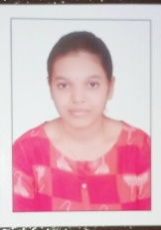 | Mathakapalli Sanwitha | 20BF1A1233 | 1Stop | 1.5 months
34 |  | N Ramesh | 20BF1A1235 | Green Tree SoftTech | 1 month
35 | 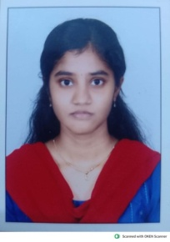 | S Ushasri Gajal | 20BF1A1250 | Oasis Infobyte | 1 month
36 | 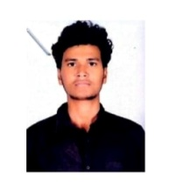 | Doddi Naveen | 20BF1A1215 | 1Stop | 1.5 months
37 |  | Gadi Mahathi Prathima | 21BF5A1204 | Oasis Infobyte | 1 month
38 |  | Shaik wazid | 21BF5A1206 | Oasis Infobyte | 1 month
39 |  | A.Mounika Sai | 20BF1A1205 | 1Stop | 1.5months
40 |  | N Venkata Sai Sankar | 20BF1A1239 | 1Stop | 1.5 months
41 | 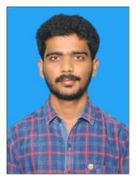 | M Suresh | 20BF1A1231 | 1stop | 1.5 months
42 | 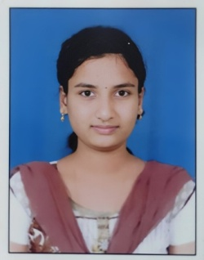 | POTHURI MOUNIKA SRIVALLI | 20BF1A1246 | Mentorskool | 6 months
43 |  | P. Sreeja | 20BF1A1244 | 1stop | 1.5 months
44 |  | B Sravan Kumar | 20BF1A1207 | Salesforce | 2 months
45 |  | C. Sasidhar Reddy | 20BF1A1213 | APSCHE-EDUSKILLS | 2 months
46 |  | D. Rohith Reddy | 20BF1A1214 | APSCHE-EDUSKILLS | 2 months
47 |  | P. Karthikeya Reddy | 20BF1A1245 | APSCHE-EDUSKILLS | 2 months
48 | 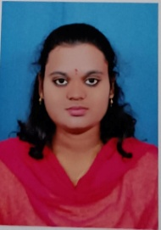 | V.Lakshmi prasanna | 20BF1A1261 | 1stop | 1.5 months
49 | 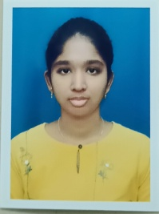 | S.Sowmica | 20BF1A1251 | Skill Vertex | 1 month
50 |  | G Nithin Kumar | 20BF1A1217 | IBM SkillsBuild | 1.5 months
51 | 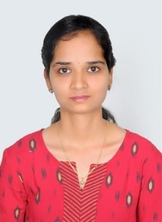 | P GNANA DEEPIKA | 20BF1A1240 | 1Stop | 1.5Months
52 | 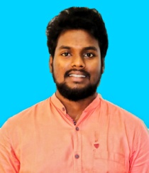 | B.yaswanth | 21BF5A1202 | 1Stop | 1.5 Month
53 | 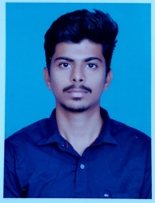 | TIRUPATHI THARUN KUMAR | 20BF1A1260 | 1Stop | 1.5 Month
54 |  | T SEKHAR | 20BF1A1262 | 1Stop | 1.5 Month
55 |  | G MANOJ | 20BF1A1216 | Green Tree softtech | 1 month
56 |  | S Charan Kumar Reddy | 20BF1A1254 | 1Stop | 1.5 months
57 |  | G Yagnesh Reddy | 20BF1A1218 | 1Stop | 1.5 months
58 |  | G Dedeepya | 20BF1A1221 | 1Stop | 1.5 months
59 |  | T.Nikhitha | 20BF1A1259 | Assure think | 1 month
60 | 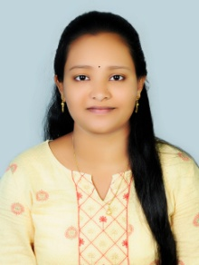 | k kusuma | 20BF1A1263 | 1Stop | 1.5 months
61 | 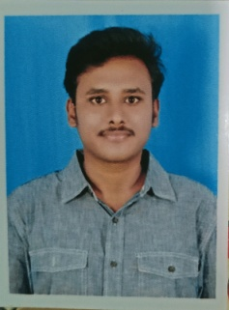 | Agavinti Guru Jeevesh | 20BF1A1201 | Green Tree SoftTech | 1month
62 |  | G. Tejesh | 20BF1A1220 | Green Tree SoftTech | 1month

