Information technology placement List for 2020-2024 batch
S.no | Rollnumber | Name | photo | Company | Package | Year
1 | 20BF1A1208 | BATHALA AKSHAY | 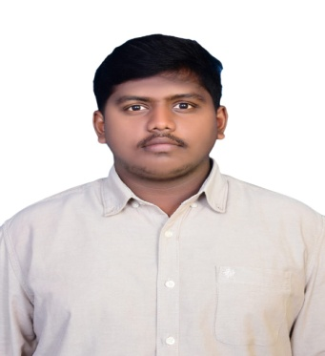 | QSPIDERS | 3.8LPA-4.5LPA | 2024
2 | 20BF1A1212 | CHILLARA MALLIKARJUNA |  | QSPIDERS | 3.8LPA-4.5LPA | 2024
3 | 20BF1A1223 | KASTURI DILEEP CHAKRAVARTHI | 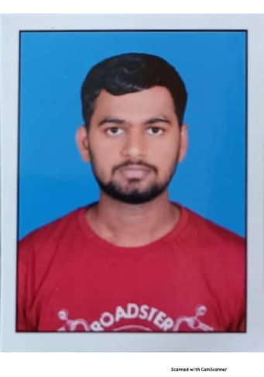 | RENAULT NISSAN | 4.25LPA | 2024
4 | 20BF1A1224 | KILIVETI CHANDU |  | RENAULT NISSAN | 4.25LPA | 2024
5 | 20BF1A1233 | MATHAKAPALLI SANWITHA | 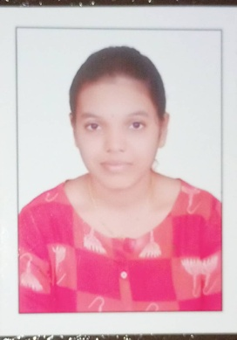 | CHEGG INDIA | 3.6LPA-9.6LPA | 2024
6 | 20BF1A1237 | NELAKURTHI MEGHANA | 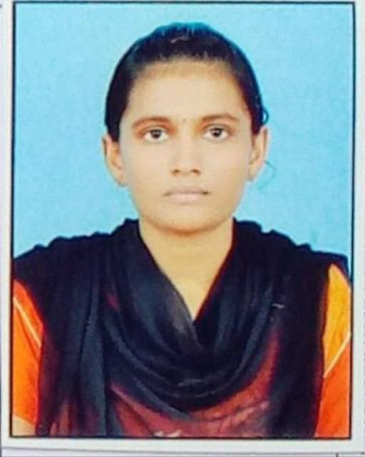 | RENAULT NISSAN/QSPIDER | 4.25LPA | 2024
7 | 20BF1A1238 | NELAPATI DRUVA SADVIK KUMAR | 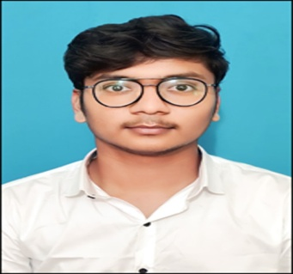 | EXCEL R/SUTHERLAND | 3.6LPA/3LPA | 2024
8 | 20BF1A1240 | P GNANA DEEPIKA | 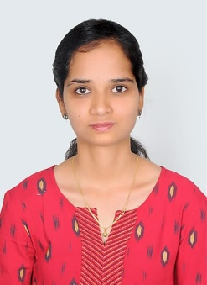 | EXCEL R | 3.6LPA | 2024
9 | 20BF1A1243 | PAPUDIPPU SANDHYA | 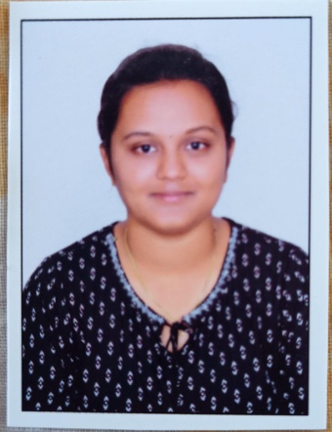 | QSPIDERS/EXCEL R/SUTHERLAND | 3.8LPA-4.5LPA/3.6LPA/3LPA | 2024
10 | 20BF1A1246 | POTHURI MOUNIKA SRIVALLI | 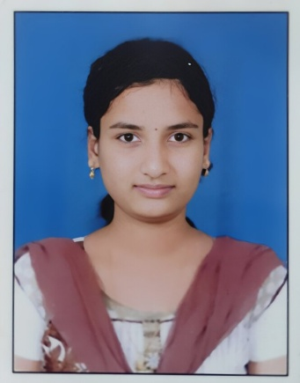 | RENAULT NISSAN | 4.25LPA | 2024
11 | 20BF1A1249 | SAMUDRALA YUVA VARNIKA | 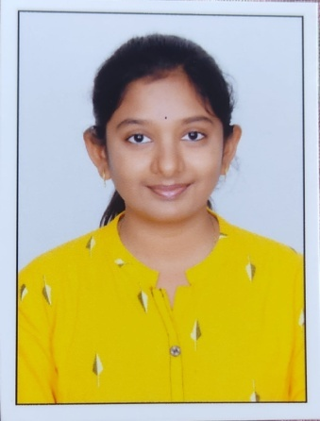 | EXCEL R | 3.6LPA | 2024
12 | 20BF1A1250 | SANGANAPALLI USHASRI GAJAL | 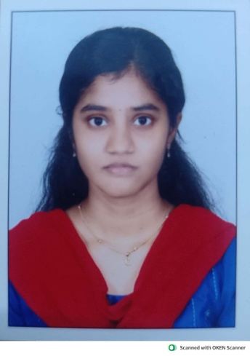 | SUTHERLAND | 3LPA | 2024
13 | 20BF1A1255 | SINGAM REDDY GARI DIVYA SAI |  | RENAULT NISSAN/INTELLIPAAT | 4.25LPA/7.25LPA | 2024
14 | 20BF1A1256 | SIRIGIRI SIREESHA | 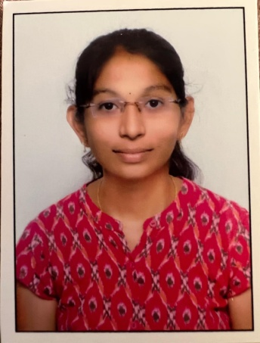 | EXCEL R | 3.6LPA | 2024
15 | 20BF1A1260 | TIRUPATHI TARUN KUMAR | 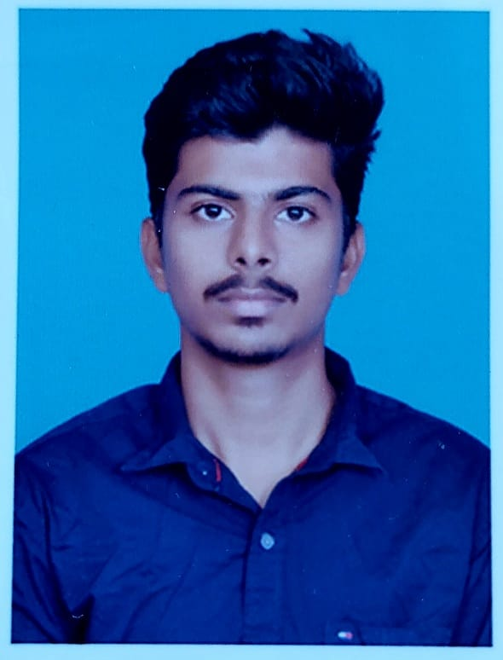 | CHEGG INDIA | 3.6LPA-9.6LPA | 2024
16 | 20BF1A1264 | SINGHAM YASWANTH | 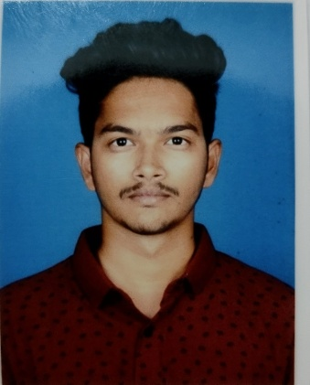 | SUTHERLAND | 3LPA | 2024
17 | 20BF5A1204 | GADI MAHATHI PRATHIMA | 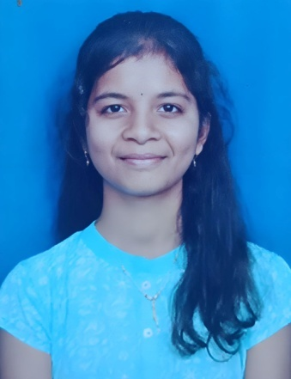 | QSPIDERS/ACCENTURE/CHEGG INDIA | 3.8LPA-4.5LPA/4.5LPA/3.6LPA-9.6LPA | 2024

