**INDUSTRIAL VISITS**

**Organized by Department of Electronics & Communication Engineering**

**INDUSTRIAL VISIT DETAILS:**

**NAME OF THE INDUSTRY VISITED : U R RAO SATELLITE CENTER**

**PLACE OF THE INDUSTRY VISITED : BANGALORE**

**DATE OF VISITED : 05th April 2023**

**YEAR & SEM OF STUDENTS VISITED : III ECE A & D**

**STRENGTH OF STUENTS APPROVED : 70**

**NAME OF THE FACULTY VISITED : Sk.Allabaksh, V Mahesh, R Nanda**

**Kumar, T. Swarna Latha**

**Overview: U R Rao Satellite Centre (URSC**

U R Rao Satellite Centre is the lead centre of the Indian Space Research Organisation(ISRO) responsible for design, development, assembly & integration of communication, navigation, remote sensing, scientific and small satellite missions.

The specialised teams of scientists, engineers and technicians of URSC have built more than 90 complex & advanced satellites for various applications in areas of telecommunications, television broadcasting, VSAT services, tele-medicine, tele-education, navigation, weather forecasting, disaster warning, search and rescue operations, earth observations, natural resource management, scientific and space science etc.

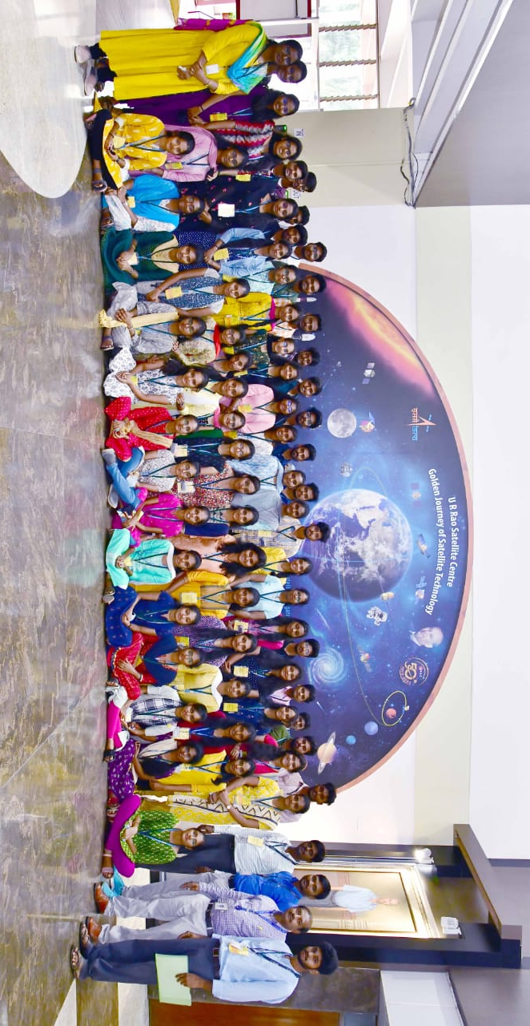

**INCHARGE HOD-ECE**