NAME OF THE EVENT : Webinar On "Higher Education & Career Opportunities Aboard

DATE : 7th July, 2023

TIME : 01:30 PM – 02:40 PM

VENUE : Google Meet

MEET LINK : https://meet.google.com/cxu-pfem-swq

PARTICIPANTS : 97

RESOURCE PERSONS : Ms A Sai Kavya & Ms B Rajitha.

Details of Resource Persons:

B Rajitha,MSC Information & Systems, University of Portsmouth, UK.

A Sai Kavya,MSC Business & Management, University of Portsmouth, UK.

**GLIMPSES OF THE EVENT:**

The Event A Webinar on “Education & Career Opportunities Aboard “hosted by M. Pavithra , Vice Chair of SVCE-IEEE-SPS Society .

Mr. Allabaksh , Advisor of IEEE SVCE SPS & COMSOC Chapter had addressed the gathering and introduced the alumni of the college.

Next Dr. D Srinivasulu Reddy Sir, HOD of ECE had addressed the gathering .He stated that SPS & COMSOC Chapters plays an important role in society. He also discussed about career opportunities abroad.

Next Dr. N Sudhakar Reddy Sir, Principal of S.V.College of Engineering had addressed the gathering. He Congratulated our Alumni students on their achievement and success for their higher studies at abroad. He asked to share their experience and insights.

Next With the permission of Dr. N Sudhakar Reddy Sir, announced the new EXECOM members of Signal Processing Society and Communication Society.

Next C. Deepika had introduced Guest speakers B.Rajitha mam and A.Sai Kavyamam and had a brief note about them to the audience. Later the session handed over to the speakers.

A. Sai Kavya mam explained why is higher education important? What are the Exams we have prepare. According to her , it helps individuals gain knowledge and skills that are necessary for their personal and professional growth. Entrance exams like IELTS, GRE, and TOFEL etc.

Rajitha mam continued the session about How the visa process, Tuition fee, course Modules and Placements .The Visa process to the UK can be quite involved and requires careful attention to detail. It typically involves filling out an application, providing supporting documentation, attending an interview. It provides opportunities for individuals to explore their interests and passions, and prepares them for their future careers.

They had clarified the queries of the audience about the higher studies and visa process in the session.

Finally it came to an end with vote of Thanks by Abhinaya Varma.

Photos

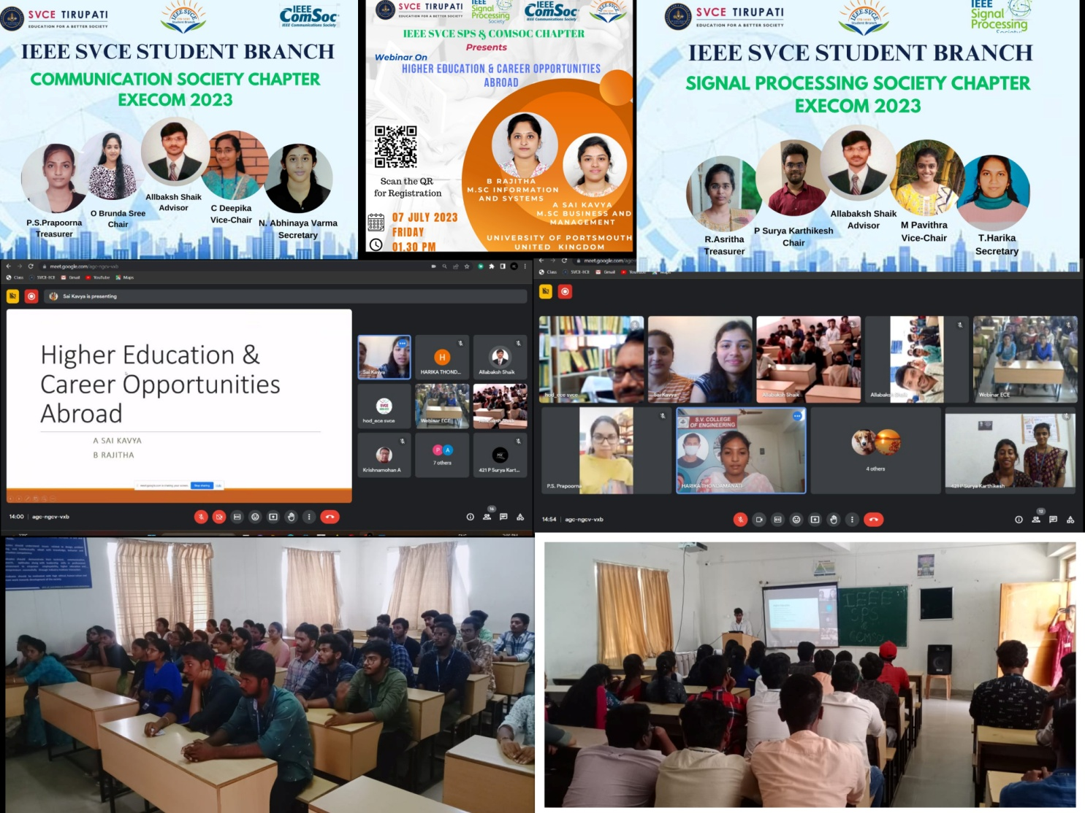

**NAME OF THE EVENT :**  **Webinar On "AWS DEVOPS in Real Time "**

**DATE : 12th July, 2023**

**TIME : 10:00 AM – 12:30 PM**

**VENUE : I Block E ClassRoom**

**PARTICIPANTS : 70**

**RESOURCE PERSONS : Mr. B Ravi Teja.**

**Details of Resource Persons:**

**B Ravi Teja** is SVCE ECE Alumni.

He has 4 years of experience in AWS Devops.

He had worked for Cognizant, Infosys.

Currently he is working at **JP Morgan Chase and Co.**, Largest leading **bank in U.S.A**.

**Infosys** certified **Devops Professional** and continuing automation in the field of **Development and Operations in Cloud Computing.**

**GLIMPSES OF THE EVENT:**

The event **“AWS – DevOps in Real Time”** hosted by M. Pavitra, Vice Chair of SVCE IEEE SPS Society.

Next we invited our dignitaries Dr. D Srinivasulu Reddy Sir, Dr. N Sudhakar Reddy Sir, and our Chief Guest Mr. B Ravi Teja on the dias. It was our tradition to begin with prayer song, Ms Geethika and Saranya Chowdary sang the prayer song.

Next Dr. D.Srinivasulu Reddy sir, HOD of ECE had addressed the gathering. He introduced our guest Mr. B. Raviteja who is alumni of SVCE ECE. He also discussed about his efforts and interest towards his studies and his passion to learn new things.

Next Dr. N.Sudhakar Reddy sir, Principal of SVCE, Tirupati had addressed the gathering. He discussed about the importance of AWS (Amazon Web Services) and some basic information about it. He inspired us by introducing our guest Mr. Ravi Teja who is more passionate & focused towards his dreams and goals.

Next P. Sharanya Chowdary had brief out the profile of our Chief Guest Mr. B. Raviteja and hand over to the speaker Ravi Teja sir, to address the gathering and he told his experiences.

Next we requested our dignitaries to present gifts, which were sent by IEEE SPS society to our IEEE members and next we had a break for 15 minutes and the session started and handed over to Mr.Ravi Teja.

Mr.Ravi Teja explained us about AWS and why everyone show interest to choose AWS and how they cope up with this AWS. He also described how this rapid increase of the AWS has acquired in limited time. He also explained the main regions of this service centre and global infrastructure of this AWS. He explained this topic in our terminology with some simple sentences and with the help of our day to day modern technology. He also explained why he chooses AWS and what basic steps of these services are and he also took acceptance from his company to make us know about the importance of this topic. He also discussed what basic techniques to perform in our interviews are and how to run & to acquire new things in this modern technology. He makes us to ask as many as questions to get a self gaining motive and to be like a professional. According to him, in this busy world opportunities are increasing and technology also increased. To be more advance we have be more passionate on our main motive. He also suggested us to do AWS certification and appreciated the certified students.

Next he discussed how AWS is useful and also the present scenario in foreign countries. Further he concluded how the AWS embedded service looks like how they used to work on that in the company environment.

Next Mr Ravi Teja had some queries and discussed among the students.

Next C. Deepika invited our beloved Principal sir, to facilitate our Chief Guest Mr. Ravi Teja with a momento.

Finally it came to an end with vote of thanks by R Arshitha .

***Photographs Of The –***

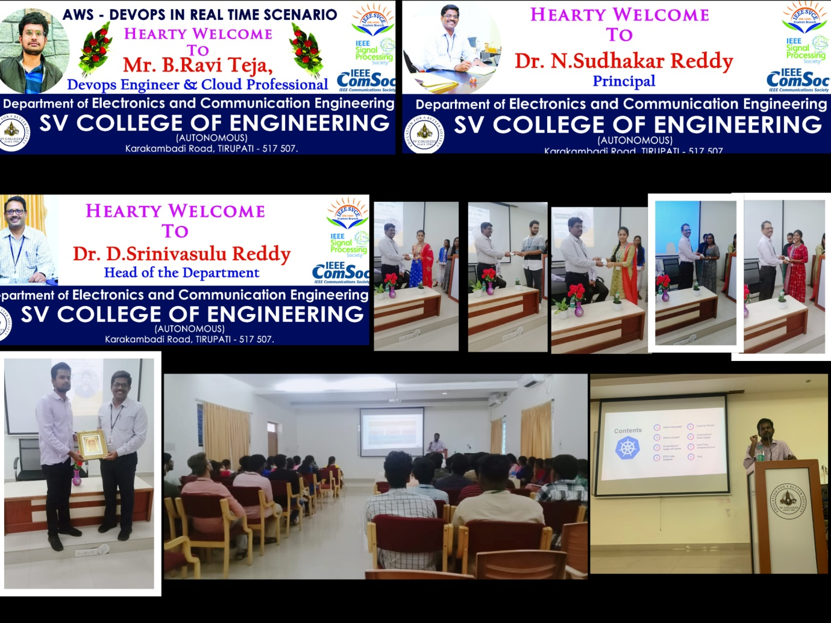

**NAME OF THE EVENT :"SVCE EduSTEP 2023"**

**DATE :23rdSeptember , 2023**

**TIME :08:30 AM – 05:30 PM**

**VENUE :Placement Seminar Hall**

**PARTICIPANTS :200**

**RESOURCE PERSONS :**

**Mr. M Sai Prasanth, M/s. Guntur Renu, M/s Divya Chhabaria.**

**Details of Resource Persons:**

**Mr. M Sai Prasanth,**Chair, Young Professional Adhoc Committee member.

**M/s. Guntur Renu,** Vice Chair of Professional Activities and Strategies at IEEE Educational Society YP Adhoc Committee**.**

**M/s Divya Chhabaria,** Vice Chair, (Step Activities) IEEE Educational Society YP Adhoc Committee, a Freelancer Web & DevOps Engineer.

**GLIMPSES OF THE EVENT:**

A Session on “SVCE EduSTEP 2023 ” hosted by O Brunda Sree, Chair,

C Deepika, Vice Chair, IEEE SVCE COMSOC chapter.

**Dr. N Sudhakar Reddy** Sir,Principal of S V College of Engineering, Senior Member and Branch Counselor of IEEE SVCE SB had addressed the gathering and delivered a session on securing funding for IEEE activities, including those related to an IEEE chapters at S V College of Engineering (SVCE), typically involves a structured process and adherence to IEEE guidelines.

Next **Dr. D Srinivasulu Re**ddy Sir, HOD of ECE had addressed the gathering. He stated that SPS & COMSOC Chapters play an important role in society. He also discussed career opportunities abroad, conducted a session on the Young Professionals Society, that provided clarity on its mission and aim. Includes that, IEEE Young Professionals is a dynamic community within IEEE that focuses on supporting the career development and professional growth of early career engineers and technologists.

Next **Mr. Allabaksh**, a Senior Member, Advisor of IEEE SVCE SPS & COMSOC Chapter addressed the gathering and presented a session on awareness of IEEE, YP and how to secure funding.

Next M Pavithra introduced Guest speaker **M Sai Prashanth** sir and had a brief note about them to the audience. Later the session was handed over to the speaker.

**M Sai Prashanth** sir explained what Block-chain is. Also, the need for Block-chain analysis and its applications. Sir also provided hands-on experience to the participants.

Next Neha introduced Guest speaker Divya Chhabaria madam and had a brief note about them to the audience. Later the session was handed over to the speaker.

Divya Chhabaria madam casted clarity on APIs (Application Programming Interfaces), a critical component of modern software development, enabling different applications and systems to communicate and share data and functionality, Applications and careers related to APIs.

Next C Deepika introduced Guest speaker Guntur Renu madam and had a brief note about them to the audience. Later the session was handed over to the speaker.

Guntur Renu madam focused on Cyber-Security, which stands for a wide range of practices, technologies, and strategies to protect digital systems, networks, and data from various threats and vulnerabilities.

Finally, it came to an end with vote of Thanks by Abhinaya Varma.

***Photographs Of The –***

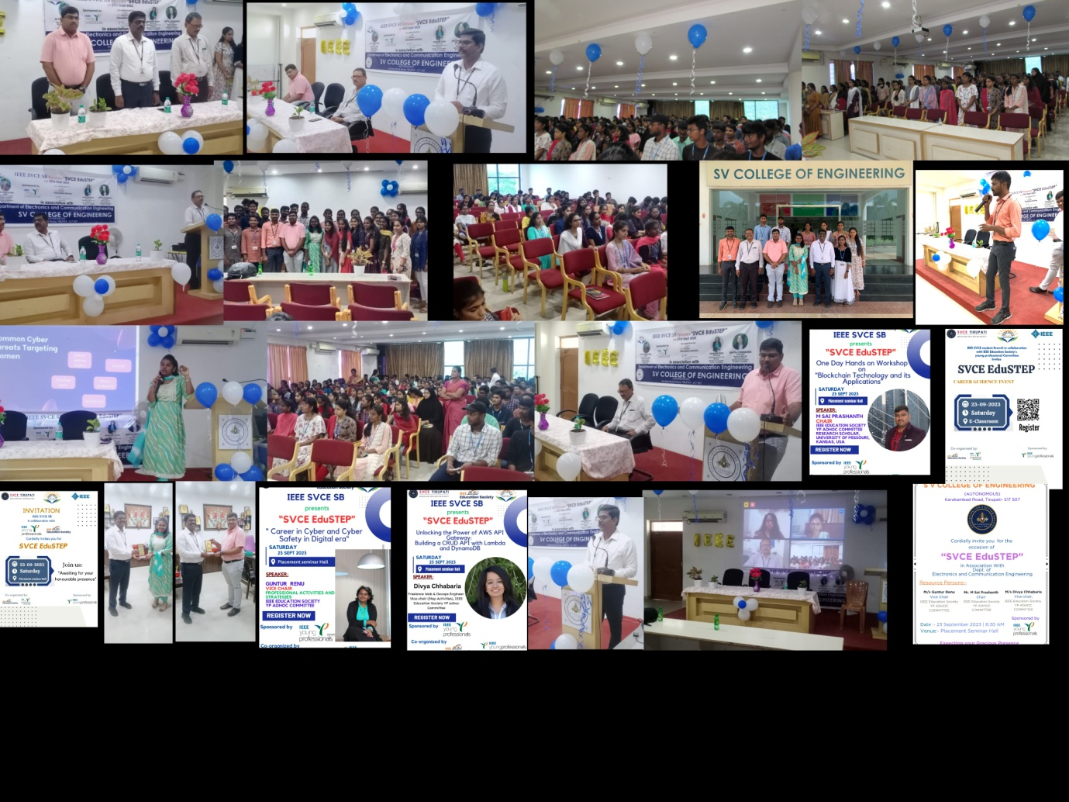

**NAME OF THE EVENT :**

**Webinar On "** **TechAware Empowering Through IEEE ComSoc"**

**DATE : 7th December, 2023**

**TIME : 09:00 AM – 04:15 PM**

**VENUE : III Block**

**PARTICIPANTS : 120**

**RESOURCE PERSONS : Dr. N Sudhakar Reddy, Dr. D Srinivasulu Reddy, Allabaksh Shaik.**

**Details of Resource Persons:**

**Dr. N Sudhakar Reddy, Senior Member in IEEE and Principal, SVCE.**

**Dr. D Srinivasulu Reddy, HOD-ECE, SVCE.**

**Allabaksh Shaik, Senior Member in IEEE and Advisor of SPS & ComSoc Chapters.**

**GLIMPSES OF THE EVENT:**

The Event “ **TechAware Empowering Through IEEE ComSoc** ” hosted by O. Brunda sree , Student Chair for IEEE Communication Society.

IEEE Sponsored by IEEE Comsoc conducted the following events to have a glimpse on IEEE Comsoc membership program and collected interested students to join IEEE ComSoc.

**Technical Events :** Techno Connection , Essay writing , Just a Minute , Techno Quiz , Poster Presentation

**Non Technical Events :** Food Challenge , Virtual Reality , Balloon Balance , Painting

Event started with **Techno connection** at 9:00 am by Amshu , Gayathri , Sravani , Bharathi .

**Essay Writing** conducted by T .Harika , R. Asritha at 10:00 am .

**JAM** (Just A Minute) conducted by N .Abhinaya varma , O. Brunda sree at 11:30 am .

**Techno Quiz** conducted by C. Deepika , P S Prapoorna at 12:00 pm .

**Poster presention** conducted by Sharanya at 1:00 pm

After all the technical events were completed at 1:30 PM, everyone gathered for a well-deserved lunch.

**Painting** conducted by P.Saranya at 2:00 PM.

**Virtual Reality** conducted by Puneeth

**Food Challenge** and **Balloon Balance** by Jyothsna reddy, Sharanya.

**Flash Mob** by IEEE ComSoc Students for encouraging.

The non-technical events kicked off at 2:00 PM with an exciting Virtual Reality experience. Participants then took on the challenge of the Food Challenge and tested their balancing skills in the Balloon Balance event, starting at 2:30 PM. The atmosphere must have been filled with laughter and friendly competition!

Our esteemed college principal Sir, inaugurated the event and showed great appreciation for all the coordinators. The printed t-shirts added a touch of unity and excitement to the occasion. The coordinators worked tirelessly to ensure everything ran smoothly, and their efforts were recognized and applauded by Sir.

ECE HOD Sir took the opportunity to express his appreciation for the hard work and dedication of all the coordinators. Their efforts made the event a resounding success. He also awarded prizes to the winners and runners, recognizing their outstanding performances.

As the clock struck 3:00 PM, all the events came to a close. To wrap up the day on a high note, the IEEE coordinators surprised everyone with an energetic flash mob! It must have been a thrilling and unforgettable moment for everyone present.

At last Event ended with vote of Thanks by C.Deepika

***Photographs Of The –***

