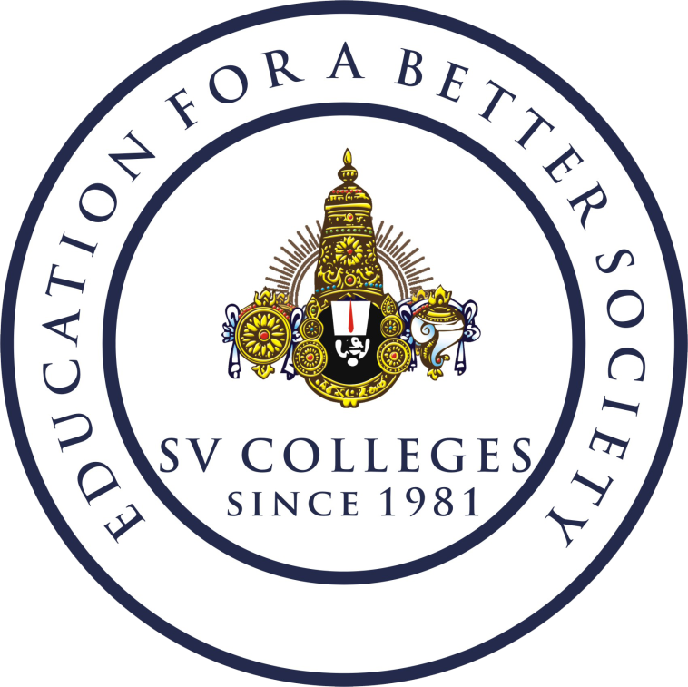**SRI VENKATESWARA COLLEGE OF ENGINEERING**

**(AUTONOMOUS)**

(Approved by AICTE | Accredited by NAAC with ‘A’ Grade |

Accredited by NBA (CSE, ECE, EEE, CE, ME & IT) | Permanently Affiliated to JNTUA)

Karakambadi Road, Tirupati - 517 507.

**Department of Mechanical Engineering**

MAJOR FACULTY ACHIEVEMENTS

Academic Year: 2022-23

**Awards:**

1. Mr.Gadhamsetty Gurumahesh, received “Guru Spandana Puraskar 2022” award from SPANDANA EDA INTERNATIONAL FOUNDATION in Association with Yogi Vemana University, YSR, Kadapa – November 2022

Academic Year: 2021-22

**Awards:**

1. Dr.K.Renugadevi, received “Women Icons Asia Technology Award” award from Women Icons Network – March 2022

2. Dr. Jagath Narayana Kamineni, Published a Book of Title “Advances and applications of biofiber-based polymer composites, Book: Advances in bio-based fiber book”, **ISSN/ISBN No. - 978-0-12-824543-9** in the year Jan 2022

3. Dr N Rajesh, Published a Book of Title “Development of Al6061/CNT Metal Matrix Nano Composites and Optimization of its process parameters in drilling”, **ISSN/ISBN No. - 978-9994984695** in the year Dec 2022

4. Dr N Rajesh, Published a Book of Title "Workshop/Manufacturing Practices", **ISSN/ISBN No. - 978-93-91505-80-6** in the year Dec 2022

Academic Year: 2020-21

**Awards:**

1. Dr. M Chandra Sekhara Reddy, Published a Book of Title “Heat Transfer Enhancement in Automobile Radiator Through the Application of CuO Nanofluids”, **ISSN/ISBN No. - 978-981-33-4443-3** in the year April 2021

2. Dr. K. Madhivanan & Dr. N. Rajesh, Published a Book of Title “Reviving Humanity During Pandemic in India”, **ISSN/ISBN No. - 978-81-949267** in the year 2021

3. Dr.N.Rajesh, Published a Book of Title “A Hand book on Engineering Graphics”, **ISSN/ISBN No. - 978-93-91216-71-9** in the year 2021

**INCHARGE HOD**